THE ROLE OF INSURANCE IN MINIMIZING BUSINESS RISK IN SMALL AND MEDIUM SCALE ENTERPRISES

(A CASE STUDY OF SMEs IN SOKOTO STATE)

ABSTRACT
SMEs are noted as the foundation of the emerging private sector in developing countries and government assistance is paramount to sustaining contribution to the country’s economy enhance (World performance of SMEs, little or no attention is given to the sector to become business recovery conscious in moments when disaster strikes. Events such as violent floods, fire outbreaks, traffic accidents, occupational hazards, accidental damage to properties and harm caused to lives, theft and armed robbery, as well as other unforeseen events have slowed down private sector investment activities, and in some instance discontinued the existence of businesses. The need to possess appropriate insurance policy cover is significant and beneficial to both public and private stakeholders; and more importantly to the survival and success of the Small and Medium Enterprises (SMEs) sector. An empirical study of 203 SMEs was done, structured questionnaires were administered to SME owners. Data was analysed and the results illustrated factors such as the reliability of an insurer, staff knowledge and brand name of the insurer have a great impact on the decision made by SMEs to build a relationship with insurance providers. The respondents, who had been approached by an insurance broker and received training, had a business relationship with an insurance provider. This helps to reach the conclusion that any form of interaction between SMEs and insurance providers helps to facilitate a business relationship. The aim was to discover if SMEs used insurance as a risk management tool. The results have shown that most of the SMEs do not have insurance policies for their businesses, and the level of information on insurance is relatively low. Owners of SMEs are required to be educated on the need to have insurance and appropriate insurance to recover business losses associated with their operations through periodic workshops organised by industry players. The need to enforce the Insurance Act on fire and liability insurance to ensure compliance is paramount to enhancing business recovery mechanism for the sector.

TABLE OF CONTENTS

CHAPTER ONE: INTRODUCTION
  - Background to the Study
  - Problem Statement
  - Objectives of the Study
  - Research Questions
  - Significance of the Study
  - Scope and Limitation of the Study

CHAPTER TWO: LITERATURE REVIEW
2.1 Historical Framework of Insurance
2.2 Concept of Risk and Risk Management

2.3 Risks and Uncertainties

2.4 Corporate Risk and Classification of Risks

2.4.1. Hazard risk
2.4.2. Financial risk
2.4.3. Operational risk
2.4.4. Strategic risk
2.5 Risk Management

2.5.1. Risk Management in Organizations’ Operations
2.5.2. Risk Management as a Process
2.5.3. Enterprise Risk Management
2.5.4. Insurance
2.6 Theoretical Framework
2.7 Conceptual Framework

2.8 Small Businesses

2.8.1 SMEs and micro enterprises
2.8.2. Risks specify to small businesses

2.8.3. Risk management in SMEs

2.8.4 Project Risk Management in SMEs

2.8.5 Risk Management in Small Technology Firms
2.9 Principles of Insurance
2.10 The Role of Insurance in Sustaining Small Businesses

CHAPTER THREE: RESEARCH METHODOLOGY
3.1 Population of the Study
3.2 Sample and Sampling Technique
3.3 Research Instrument
3.4 Validity and Reliability
3.5 Research Design
3.6 Procedure for Data Administration
3.7 Method of Data Analysis

CHAPTER FOUR: DATA PRESENTATION AND ANALYSIS
4.1 Data Presentation

4.2 Hypothesis Testing

4.2.1 Primary Hypothesis

4.2.2 Secondary Hypothesis
4.3 Discussion of Results

CHAPTER FIVE: SUMMARY, RECOMMENDATIONS AND CONCLUSION
5.1 Summary
5.2 Recommendations
5.3 Conclusion

REFERENCES

CHAPTER ONE
INTRODUCTION
  - Background to the Study
Life is full of risks; expected or unexpected. In recent years there have been a lot of disasters and uncertainties affecting personal lives and the business environment across the globe. These events have had adverse effects on the socioeconomic activities on developed and developing nations; particularly Nigeria. There have been violent floods, fire outbreaks, traffic accidents, occupational hazards, accidental damage to properties and harm caused to lives, theft and armed robbery, as well as other unforeseen events that impact negatively on various economic ventures; especially the private sector investment activities. These mishaps remind us of the need to adopt risk management measures. Risk is everywhere but the business world is much exposed to it. To overcome the losses arising from these risks some take up insurance, others do not.
Aizenman and Marion (1999), highlight the adverse effects of risks on investment using macroeconomic data from more than forty (40) developing countries. They emphasized the fact that the uncertainty about business decisions in the future and the resulting gains cannot be optimistic. Despite efforts by successive governments through economic reforms to heighten the private sector to complement government’s investments and enhance economic growth, the sector’s response is relatively low; and this constitutes a major problem.
Entrepreneurs make decisions regarding their investment in a dynamic and risky environment. The outcomes of their decisions are generally not conclusive due to the uncertainties associated with the future outcomes. Variability in future outcomes is the biggest source of risk, particularly among Small, and Medium Scale Enterprises (SMEs). The use of insurance as a risk mitigation tool provides confidence and prospects in successful business decisions, however to some degree.
The basic function of insurance is risk transference; risk is transferred from one party (the insured) to another party (the insurer). The transfer of risk by no means eliminates the possibility of misfortune, but the insurer provides financial security and tranquility for the insured when the insured risk occurs. In return, an insured pays a premium in a very small amount when compared with the potential losses that may be suffered (Morton, 1999).
Insurance as a risk management tool in Nigeria is made extensive and mandatory by the Insurance Act, 2006 (Act 724). The Act makes it compulsory for private commercial property owners such as hotels, restaurants, hospitals and clinics, Auto shops, manufacturing firms and many other related businesses to obtain fire and liability insurance just as it is compulsory for vehicle owners to obtain the Third-Party Motor Insurance cover under the compulsory third party
motor insurance Act 1958 (Act 42). Sections 1 not construct or cause to be constructed a commercial building without insuring with a registered insurer the liability in respect of construction risks caused by negligence or the negligence of servants, agents or consultants which may result in bodily injury or loss of life to or damage to property of any workman on the site or of any member of the public; every commercial building shall be insured with an insurer against the hazards of collapse, fire, earthquake, storm and flood, and an insurance policy issued for it; the insurance policy shall cover the legal liabilities of an owner or occupier of premises in respect of loss of or damage to property, bodily injury or death suffered by any user of the premises.
The compliance to this however, is in doubt as there have been instances where insurance policies that were to be applied were not covered. The need for insurance covers to minimize the effects of hazards to SMEs, Government Agencies and Departments; hence, the call on government with other stakeholders to assist victims.
  - Problem Statement
Risk is one of the most overlooked areas in SMEs in spite of the fact that it is clear to most entrepreneurs that, operating any business involves risk such as losses associated with property, income, injury and liability. These risks are inevitable to most entrepreneurs in businesses. Prudent business owners take steps to minimize the risk of their businesses in other to maximize returns on investments. A good risk management system is a continuous process of analysis and communication to select the appropriate tool to manage risk.
SMEs in Nigeria serve as vital indicative sources of growth, technological innovation and flexibility. However, they are saddled with towards growth and development strategies. SMEs are exposed to many risks in their ordinary course of business, such as interest rate risk, foreign exchange risk, market risk, natural disasters, political risk, and technological risk and so on, that minimize their profit by increasing their financial losses. However, insurance enshrined in sections 183 and 184 of the Insurance Act, 2006 (Act724) to serve as a buffer in the event of mishaps is not given the attention it deserves regardless of its significance to mitigate the effects of risks resulting from disasters or unexpected events. In Sokoto, the level of patronage of insurance by SMEs as a risk transfer mechanism to mitigate risks such as collapse of building, fire outbreaks, accidents, burglary, business interruptions, and dishonesty of personnel tend to be wavy. What were the recovery measures in the wake of the potential losses and financial hardships? In view of this, the researcher examined the extent to which insurance was used as a risk management tool by SMEs.
  - Objectives of the Study
The research broadly sought to assess the extent to which SMEs adopt insurance as a risk management and minimizing tool and the benefits therein. Specifically, the research intended to achieve the following objectives to:
- Identify what business risk(s) SMEs face;
- Examine the response of SMEs towards the use of non-life insurance to mitigate pure risk(s);
- Assess the benefits SMEs derive from using insurance as a risk management tool;
- Identify any problems SMEs encounter in using insurance; and
- Find out solutions to the challenges that SMEs encounter in using insurance.
  - Research Questions
The main research question addressed was: do SMEs use insurance to mitigate business risk(s)? The specific related questions to solve the research problem included the following:
- What were the risk exposures that an SME was faced with?
- Did entrepreneurs of SMEs have enough insurance for their businesses?
- What was the level of response to using insurance as a risk management tool?
- What benefits did SMEs derive from using insurance as a risk management tool?
- What were the problems that SMEs encounter in using insurance?
- What were the solutions to overcome the challenges that SMEs encountered in using insurance?
  - Significance of the Study
The study would help identify the reasons for the level of patronage of insurance as a risk transfer mechanism and create a changed behaviour of the owners of SMEs. The research would benefit, risk managers, business consultants and business continuity consultants by identifying areas that they might need to consider when preparing disaster recovery plans, particularly for SMEs.
Findings that emerged from the study would serve as a spring board to generate interest for further research into the other aspects of insurance challenges. The research work would also be of enormous assistance to various levels of educational institutions in the country, especially the universities as reference material for further studies and research work on insurance as a risk management strategy. The study would further contribute to the existing literature on mitigating and providing confidence to entrepreneurs in their investment decisions. Also, the insurance regulator in the country should find it useful to adopt pragmatic means to enforce the unenforced insurance Acts in the country. Lastly, it might influence the level of premium incomes of non-life insurance companies in the country.
  - Scope and Limitation of the Study
The study covered the use of insurance as a risk management tool by SMEs, evidence and
prospects in the metropolis. Four categories of insurance protection were classified for any businesses: property, liability, people and income (Dorfman, 2008). These categories remained the focal points of reference in the research. Indemnification and risk pooling of the various categories of insurable risks enhance commercial transactions and the provision of credits by reducing losses. The research took a period of five months. Organizations in Sokoto Metropolis were used for the area of study. It is the central business district and the capital of the region.

CHAPTER TWO

LITERATURE REVIEW
2.1 Historical Framework of Insurance
There are lot of versions on the origin of insurance generally as its origin is lost in antiquity. In ancient Babylonia, where from the confluence of the Tigris and Euphrates rivers, enterprising merchants sent caravans and ships to trade with all parts of the known world principally with Egypt, Phoenicia, India Achaemanian monarchs, Greeks, Hindus Romans and China. To reduce the risk of robbery, plunder and capture for ransom, the Babylonians devised a system of contracts in which the supplier of capital for a venture agreed to cancel the loan if the trader was robbed of his goods. The trader who borrowed the capital paid an extra amount for this protection (a premium) in addition to the usual interest. As for the lender, collecting these premiums from many traders made it possible for him to absorb the losses of the few. This arrangement proved to be more appealing and sensible than the earlier one of pledging not only the trader’s ships and other tangible property, but also his life (as a slave) and those of his family as well. This could be traced to the famous code Hammurabi C. 1750BC that it was practiced by early Mediterranean sailing merchants, where if a merchant received a loan to fund his shipment, he would pay the lender an additional sum in exchange for the lender’s guarantee to cancel the loan, should the shipment be stolen. The system was later known as ‘Bottomry Bond’.
The ancient insurance practices have no concrete evidence as it is presently. So, the origin of the latest insurance practices could be traced to marine insurance, which is the oldest form of insurance. The marine policies of the present form were sold in the beginning of fourteen century by the burgians (Mishra, 2007). On the demand of the inhabitant of burges, the court of flanders permitted in the year 1310, the establishment of a charter of Assurance by means of which the merchant could insure their goods, exposed to the risks of the sea. Insurance started in Italy in the 14th Century, 1350. At that period, the insurance merchants seek to obtain loan from the people in Italy, from that moment, it spreads to all other countries in the Southern Europe. In 1435, statutory enactments were made on insurance law in Barcelona in Spain which led to the codification of insurance laws in 1448.
History of insurance in England could be traced to the reign of Queen Elizabeth I, where an Act was passed by the British parliament in 1601, which set up a court of Arbitration for the settlement of disputes on marine insurance policies. At this period there were no insurance company as it is today, what existed then were merchants who prepared to share in the underwriting of a risk as related to that of insurance underwritten act of the Lloyd’s of London of today. After marine insurance in historical development, was fire insurance which got momentum in England after the great fire outbreak in 1666, which destroyed thousands of houses and prompt the first establishment of fire insurance office in 1667 in London by Nicholas Barbon. Later life assurance emerged and other contingencies policies.
Insurance has been in existence in developing nation like Nigeria for long but, the modern business was introduced into Nigeria as late as the 20th century with the establishment of trading posts in Nigeria by the European trading companies, mostly British whom started effecting insurance practices by their agents who are largely expatriate banks and traders, later appointed traders as agents and later open branches in Nigeria before the indigenous insurance companies.
The first insurance company to have a full branch office in Nigeria was the Royal Assurance in 1921 who happened to be the only one in Nigeria until 1949 when three other companies (Norwich Union Fire Insurance Society, Tobacco Insurance Company Limited and the Legal and General Assurance Society). The total number of insurance companies operating in Nigeria increased to 25 which were mainly owned by foreigners, it increased to 88 in 1984, most of which were indigenous and even later increased to about 130 but were narrowed to between 49 and 51 in 2010 (NAICOM, 2010).
Earlier in Nigeria, there was no regulation guiding insurance operation until the emergence of the first legislation, Motor Vehicle (Third Party Insurance) Act of 1945 but came into force in April 1950. This was subsequently followed by the Insurance Act of 1961 which explains the necessity for the regulation and license for insurance companies and subsequent laws like Nigerian Insurance Decree of 1976 and the Insurance Act of 2003. In 1997, the National Insurance Commission (NAICOM) was established to replace the National Insurance Supervisory Board (NISB Decree No 62) of 1992 as an apex body that regulate the insurance industry. The commission is discharging their responsibilities in ensuring sustainability of business in Nigeria by assuring that insurance companies are working to expectations, for example two (2) insurance companies and a broking firm (Alliance and General Insurance Company Ltd., A&G Life Assurance Plc., and Fidelity Bond Insurance Brokers ) were suspended from transacting further insurance business for a period of 6months with effect from August 6, 2012 for violation of the relevant provision of the commission. As at September, 2012, the licensed insurance companies in Nigeria are; Life: 17, Non-Life: 32, Composite: 10, and Re-Insurance: 2; while the insurance practitioners are; Re-insurer; 2, Brokers: 706, Loss Adjusters: 60 and the Agents: 1,668 (NAICOM, 2012).
2.2 Concept of Risk and Risk Management
There is no entrepreneurial activity that is devoid of risk except in utopia. This confirms that no matter the size and type of activities that are conducted by enterprises, they are identified with different degree of risk exposures and types (Itodo, 2011). A Risk is an uncertain event or condition that if it occurs, has a positive or negative effect. It is the possibility that something unpleasant may happen. It can be said to be variability or dispersion of returns from the one that is expected (Kurfi, 2003). It can also be viewed as a potential for realising low returns or even losing money and possibly preventing you from meeting important objectives (Bodie, Kane and Marcus, 2004). From the above definitions, it shows that risks are occurrence that deviate business owners from meeting their business objectives. And to meet their target, these risks should me properly managed.
Risk Management can be defined as the identification, measurement and economic control of risks which can threaten the assets or earning capacity of a business (Baju, 2004). It can be done through three distinctive process of Risk Identification; Risk evaluation/measurement and Risk control. Risk Identification is concerned with identifying the possible causes of loss. Risk evaluation is concerned with measuring the impact of possible loss on the enterprise by an assessment of the frequency of losses and their possible size in relation to the values of risk. While Risk control is concerned with minimising the adverse effects of loss either through prevention, retention or transfer (through insurance).

2.3 Risks and Uncertainties
It is necessary to understand that “uncertainty” is a much broader term, while “risk” is just a part of “uncertainty”. According to Frank Knight (2006), “risk” is the term used to describe cases of known probability, for example, a store can calculate the probabilities that the cashier might mistakenly check an order per every certain number of customers and hence the store account might lose some balance. Uncertainty is when you cannot calculate the probabilities or make any forecasted assumption. An example for uncertainty is to predict stock market price, for instance, fifty years in advance. Risks and uncertainties are often distinguished in the language of “statistical probability” (B. Ritholtz, 2012). Regardless of the different scope of these two terms, both risk and uncertainty might result in positive or negative impact to the business operation and require proper management.
Risks might arouse from uncertainties related to management, natural disaster, political affairs, and cultural factors. (Köster, 2009, p99). Classification of risks according to their influences or nature is the essential step to any risk management strategies (Wideman 1992, III-2).

2.4 Corporate Risk and Classification of Risks
Generally, risk is the possibility for danger, negatively unexpected circumstance to occur (Oxford English Dictionary, 2013). In most of economic publications, risk refers to the negative deviation from the plan (Maylor 2010). In finance, risk is related to the hazard towards an investment, or loan (Encyclopedia Britannica, 2013). In terms of corporate and business, risk is the possibility that an event, either expect or unexpected, may create an unfavorable effect on the organizations. Corporate risks are classified by the impact they might create on different business operational activities. This means that a risk can be repeatedly divided into different classes. Business risks, property risks, information risks, environmental risks, etc. are some common classifications. Table 1 below presents a variety of risk types faced by most organizations:

Table 1. Common Business Risk Types (David O. & Desheng W. 2008 p. 7)
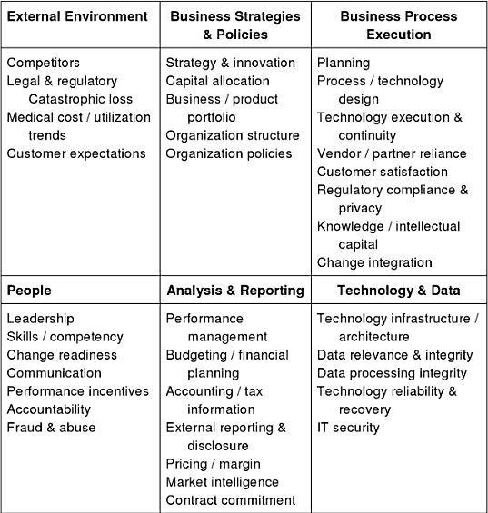
People want to avoid risk, however, the economy as a whole, encourages businesses to take risks. Business operations, the activities of extracting capitals from one source to other sources, literally mean taking risks for more profits. Moreover, taking risks in one way or another brings competition and innovation. Thus, risks are issues that needs structure management plans, to be understood, prepared for, and to be improved. Risks or uncertainties have their own distinct characteristics which call for particular assessment and management strategies. The Global Risk Alliance (2005) discussed that there are three types of risks as in Figure 1 below.
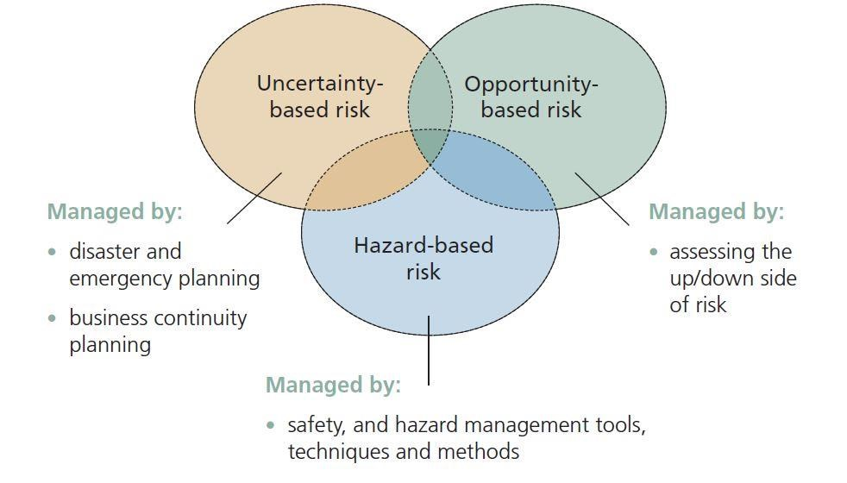
Figure 1 Three types of risk and their management. Risk Management Guide for Small Business, by Global Risk Alliance. 2005. p10.

As risks are not likely equal, based on the frequency of happening, based on level of consequences, or base on the nature of risk. These are the common ways for risks to be classified. From likelihood point, risks can be named from likely risks; possible risks; hypothetical risks to imaginary risks; where losses can happen usually, reasonably, or be theoretically possible or even unlikely exist. In this paper, the author will investigate different risk types based on the nature of them. The discussion will involve hazard risk, financial risk, operational risk and strategic risks.

2.4.1. Hazard risk
Hazard risks are risk related to working environment, property, and natural catastrophe. Originally hazards refer to potential harms that can affect health and safety of personnel of property (The University of Newcastle, Australia). Besides common hazard groups such as physical, chemical biological, mechanical and psychological which arise from workplace premises and environment or work practices, risk can grow from uncontrollable factor like natural disasters. It is commonly agreed to be employer’s responsibility to fix hazards. Exposure to hazards in workplace does not always result in injuries or severe health effects. However, preventing hazards from happening ensures personnel to work under no pressure of being harmed.
2.4.2. Financial risk
Financial risk is a broad term covering many negative risks related to financing, for instance, liquidity risk, funding risk, interest rate risk, investment risk, pricing risk, credit risk, and so on. Financial uncertainties can return as favor for one business but loss for another. For example, increasing in fuel price can plus the financial statement for a company that produce or supply fuels, but this price change can create huge extra costs for a transportation agency. The consequences and the exposure’s extent an organization may suffer from financial risks depend on the scale of the company’s financial transactions: how much of the borrowings in compare to its business scope (CPA Australia, 2006).
Financial risk management is considered a specialization of risk management. In addition to careful revise on business cash flow and operational forecast, management use hedging - including stocks, insurances, etc. – as a method for reducing risks in operations and other investments.
2.4.3. Operational risk
Operational risks frequently are summarized as human risks, due to the discussion that the human error leads to business operations failure. Nevertheless, operational risks include all risks that incur from organizations’ internal activities involving people, products or services offered, operational systems, and external factors (Global Association of Risk Professionals, 2011). Banking is the sector facing operational risks with most probabilities. The Basel II regulations (Basel Committee on Banking Supervision, 2004) listed seven categories of operational risks: internal fraud; external fraud; employment practices and workplace safety; client, products and business practice; damage to physical assets, business disruption and system failure; and finally, execution, delivery and process management.
Even though banks and investment businesses are most vulnerable to operational risks, other types of businesses share a common threat from this kind of risk. Small day to day losses due to customer dissatisfaction or bad reputation can add up and cost any firms significantly damage. Some risks might be more sensational than others; however what matters is a strong and suitable management structure according to the selected operational risk methodology. Especially, a business manager needs to build a sufficient system of staff and resources, as well as provide an appropriate leadership behavior. In addition, monitor, review and update current management data and structure is a crucial step in managing operational risks (An Oracle White Paper, 2010).
2.4.4. Strategic risk
Strategic risks imply the probabilities of a loss arising from a poor strategic business plan, decision, or from the inconsistent and inappropriate implementation according to the plan. Strategic risks pose threat to earnings, capital availability and corporation’s viability. Because strategic plans indicate the operation direction as well as framework, vision and objectives of an organization, the lower the probability of strategic risk stays, the stronger the organization is. Thus, boards of directors are focusing on how organizations identify, assess and manage their risks.
Strategic risk management requires concentrations on risks to shareholder value as the ultimate goal (Beasley, et al. 2008) while considering the effect of external and internal scenarios to the ability of organization to achieve its goals. Strategic risk management is a primary component of an enterprise risk management (ERM, to be introduced in the later part of this Literature review sector) process.
Understanding the strategies of the organization is the essential foundation step in a strategic risk assessment. The assessment process should continuously reflect the corporate model, and be supported by valid strategic risk profile, together with risk management communication and action plan. (Frigo M., et al. 2009)
2.5 Risk Management
Insurance companies have always been working with risk assessment and risk analysis to ensure their customer’s businesses and their own profit stay on track. Nowadays risk management involves every type of businesses, from regulators, debt rating agencies, international conglomerates, to small enterprises. It is not only the Enron case, or the 2008 financial crisis that stirred the whole world, but further beyond that, losses from their own operations and collapses of other enterprises make managers change to lead carefully.

2.5.1. Risk Management in Organizations’ Operations
Risk management is vital in securing the business’s capitals and other properties. However, as discussed, risk accompanies with the business’s opportunities to grow. Therefore, it is often emphasized in business strategies that risk management is not to prohibit taking risks entirely, but to understand the levels of risks, and to properly engage risks into development and growth.
On applying into operations, risk management contains a set of continuous actions: awareness, identification, evaluation, and development of risk management methods, decision making of suitable methods, implementation, and post management. While the workload increases, it is not necessary for the outcome to be excelled. The essence of risk management lies in the systematic flow of one step to another. Whilst the risk-taking behavior in corporates is encouraged, mistakenly identifying the manageable level of risks leads to inappropriate method, and finally to the loss in operation.
Risk management emphasizes the capabilities of a business to anticipate changes, not the avoid risk. Avoidance of risks means waiting for the event to happen then react to it, rather than prepare for the changes. In reality, many organizations choose to avoid risk, as in their simplest risk management strategy. In one hand, this strategy allows fully protection from particular losses. In other hand, this strategy deprives profit, and might cause another risk. (Biasi 2011 p.12).
2.5.2. Risk Management as a Process
Risk Management has been in discussion of scholars, researchers and business experts for a long time. According to a study of Southern Cross University, (2012), in the standard AS/NZS 4360:2004, risk management is defined as: the systematic application of management policies, procedures and practices to the tasks of establishing the context, identifying, analyzing, assessing, treating, monitoring and communicating.
There could be as many as possible aspects of risk management, in related to particular business sectors. Besides, financial risk management, David O. & Desheng W. in their book (2008, pp. 3) addressed risks emerging from accounting, supply chains, information system, and disaster management perspectives.
A traditional process of risk management following the guidelines of International Organization for Standardizations (ISO 31000:2009) involves 3 main steps:
- Establishing the context: this step involves identifying the entire possible field of risks and analyzing the relevant possible effects, and from there planning or mapping out the entire management strategy.
- Identification: after getting the context of possible business risks, the risk management will process to identify sources of the problems, threats, or risks. Choosing a right method to identify and analyze risks will help the preparation and prevention steps work better. However, the methods chosen are biased by cultural, organizational, politic and many other factors. Control solutions identification goes after the risk identification.
- Assessment: The final step consists of some sub-steps: establishing the likelihood and consequence descriptions, the risk rating index. Defining which consequences would lead to an extreme risk or just a general low level risk would generate an appropriate method of control. It is advisable to develop the risk management methods along with defining the level and consequences of the risks. The assessment process might involve decision making process, especially in the case of high or extreme level of risk.
For the continuous growth and later references, organizations would expand the risk management process further to the step of monitor and post-process evaluation. Regularly reviewing the risks and update the definition or methods is essential to risk management, and to the successful operation of the business.
2.5.3. Enterprise Risk Management
As businesses grow periodically, relevant risks grow at the same rate, together with new field of risk management opens up. Thus, organizations’ risk management adapts to the specialized risk by a more integrated approach: Enterprise Risk Management (hereinafter: ERM). The concept has been developed from the mid-1990s industry (David, O. & Desheng, W.) to meet the requirement of business growth and risk management. Stephen, D. (2001) extracted the Casualty Actuarial Society definition of enterprise risk management as: The process by which organizations in all industries assess, control, exploit, finance and monitor risks from all sources for the purpose of increasing the organization's short- and long-term value to its stakeholders.
While traditional risk management views risk as individual hazards, ERM puts risks in the context of business strategy, then build a portfolio of risk development. ERM provides base for risk mitigation and rational management. Traditionally risk management approaches the downside – possible losses from risk events whereas ERM scholars encourage management to recognize risks with both upside and downside factors (Investopedia, 2013).
When companies talk about ERM is when they manage risks following a framework, a tailored approach to identify, measure, respond to and prevent or monitor risks and uncertainties. The two most well-known ERM frameworks are which of Casualty Actuarial Society (CAS) and of Committee of Sponsoring Organizations of the Treadway Commission (COSO). The CAS conceptualized ERM as a means to increasing the organization’s value. The process of ERM is recognized depending on the risk types: hazard risk, financial risk, operational risk and strategic risk (CAS, 2003). COSO ERM framework is categorized into components and objectives, with highlights lie in supporting the organization’s strategy, ensuring effective and efficient use of resources, resulting in financial profit while complying with laws and regulations.
Figure 2 below reflects evaluation questions to address an effective ERM program through key ERM concepts. However different the framework management selects to apply, a risk response strategy usually involves: Avoidance – executing activities that lead to risks; Reduction – reduce the activities that lead to risks, or taking action to reduce the impact arise from risk; Alternative Actions – other steps to minimize risks; Share/Insure – finance risk or percentage of its through services; and Accept – no actions are taken against the risk (COSO, 2004).
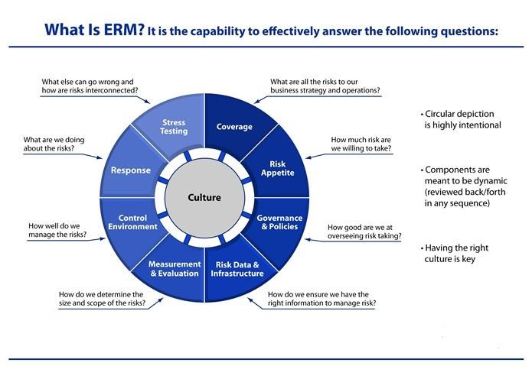
Figure 2. What is ERM? – ERM definition wheel. (Enterprise Risk Management Workbooks, The Risk Management Association).

Professional financial service firms such as Deloitte and many other provide wide range of enterprise risk management services to help organizations integrate risk management into their strategies. As mentioned, companies historically depend on purchasing insurance to stand against risks. Particularly in the U.S, many corporations are not active in presenting their risk profiles to stakeholders and society, if without an outsider’s service. Nevertheless, it is always important that management themselves need to understand risks and uncertainties, to create a stronger persuasion to investors, and to save the organizations from heavy costs of insurance. It is clear that ERM is recognized as a critical management issue, ERM tools and capabilities are enhanced by more and more companies (Towers Perrin survey No.19, 2008).
2.5.4. Insurance
There should be the understanding that risks could be managed and controlled but not totally eliminated. Thus, even with the most thoroughly planned, evaluated and implemented risk management plan, errors can unexpectedly arise at some point of the process. One of the risk management techniques is risk transfer, which involves insurance.
Insurance is one solution of organizations to hedge against threats. To be insurable, the risks should appear to match several common characteristics (Mehr and Camack, 1976. p34). For example, insurers normally agree to contract homogeneous risks, risks that historically have large number of similar events, to ensure the claim costs. Insurable risks need not to be categorized as catastrophic, but have definite loss when measuring within particular time and amount, so that the impact of risk is measurable and the benefit of the insurance can be determined. In addition, one condition made to define insurable risks is that there should not be any acknowledgement by the insurance holders or relevantly of to whom the damage or loss may happen. Insurance companies typically are equipped with professional investigation staff to check on every claim and make sure the affair is not planned by the policy holder.
Doing business means being liable to risks, from slightly to heavily. However, it is not worth insuring against all uncertainties and risks. Although insurance provide compensation for losses, choosing to insure against risk or not and choosing what to insure are decisions that need carefully consideration from management. The cost from insurance – premium – might turn to be too costly, even larger than the expected revenue. In other words, property or assets can be under insured or over insured. Under insurance happens when the insured value of the property is less than in reality. If the property or assets or insured items worth more than the insured value, then it is called over insurance and the over insurance payments are wasted. Insurance, if not in case of legally compulsory, should be the last method to solve a problem (Stanford risk management department, accessed 2013).
2.6 Theoretical Framework
It is imperative to discuss some theories that could serve as a basis for this study. Harvard School Theory of Entrepreneurship contemplated that entrepreneurship involves any deliberate activity that initiates, maintains and grows a profit-oriented enterprise for production or distribution of economic goods and services which is inconsistent with internal and external forces. It is then paramount to understand that the performance of the entrepreneur, as propounded by Harvard School Theory depend on these forces (internal and external), which losses that could arise from these forces could be covered by insurance.
Kao’s Conceptual Model of Entrepreneurship also described that entrepreneurship and creativity resulted from the interrelationship of the three essential elements of person, the task and organisational concept. He opined that person is an important element in business growth as new idea is generated and implemented through the effort of dedicated people with talent who undertakes the organisational task which are influenced by organisational strategy and external environment. He describes this environment to include available resources, infrastructure, competitive pressure, state of technology among others, which are risky to the growth of business, but such risk could be taken care of using insurance tool.
The Theory of entrepreneurship was also propounded by Frank Knight who described entrepreneur as risk takers who shoulder the occurrence of risk and uncertainty that are likely to befall them. The main features of the theory are: pure profit, situation of uncertainty, risk bearing capability etc. The theory vividly reveals that an entrepreneur is a person that is always prepared to exploit opportunities despite the existence of risk, provided there is a return in form of profit which serves as the basis for establishing the enterprise (Itodo, 2011). As described in the theory, entrepreneur always take risk to make high return on their investment, but the price of higher expected return is greater anticipated risk, which is a loss of wealth or a failure to meet investment goals (Hirschey and Nofsinger, 2008), which could be covered by respective insurance policies.
2.7 Conceptual Framework
The primary objective of starting a business by entrepreneur is to maximise its wealth, that is, to make profit, and it is understood that, making desired profit requires lot of risk taking which cannot be separated from the business world but, should be covered by insurance to sustain the business. Lot of studies has emphasised on the concept of SME’s in terms of its diverse definition among others.
The concept of insurance is described as a co-operative device to spread the loss caused by a particular risk over a number of persons who are exposed to it and who agree to insure themselves against that risk (Mishra, 2007), and He also described the function of insurance to be spreading of loss over a large number of people who agree to cooperate with each other at the time of loss. Insurance is an intricate economic and social device for the handling of risks to life and property. It is social in nature because it represents the various co-operations of various individuals for mutual benefits by combining together funds to reduce the consequence of similar risk. Simply put, insurance is the placing back of a person who has suffered a loss in the same position he was before loss occurred. It aims to eradicate the consequence of a loss by not allowing the insured to suffer the consequential loss. Risk in business cannot be averted, in as much the entrepreneur desire returns but, loss occurring due to a certain risk can be distributed among the agreed persons through the insurance company. (Bark and DeMarzo, 2007) also described insurance as the most common method to reduce risk by firm, in which they could insure their assets against hazards such as fire, storm damage, vandalism and other natural and environmental risks.
Insurance is a tool used to manage financial risk. Insurance involve two set of people, where one intends to transfer its risk to another, who on the other hand, wish to take the risk in agreement of a regular payment to be made by the person transferring the risk (insured) and with the provision of financial compensation to be made by the risk taker (insurer) if all conditions involve are met. Insurance is designed to protect the financial wellbeing of an individual company or other entity, in case of an unexpected loss. It is ensuring that the business suffering the loss will be compensated, not for the written down or market value of their building, machinery and plant, and other contents insured, but rather the cost of replacing the item with new property (Manning, 2004).

2.8 Small Businesses

2.8.1 SMEs and micro enterprises
SMEs and micro companies are business terms defining companies with number of personnel stays small, practically around ten contracted staff for micro entities, up to 50 workers as a small company, and round at approximately 250 employees to be a medium-sized enterprise. The abbreviation “SME” is used internationally nowadays.
As in a report on new definition of SME, European Commissions specified that SMEs contribute a major source of entrepreneurial skills, innovation and employment (2004, pp.5). Accordingly, to be considered a SMEs, first the business must be considered as a legal entity, and then the enterprise will be assessed and levels by three criteria: staff headcount, annual turnover, and annual balance sheet (2004, pp.12-15).
As it is significantly concerned with the number of employees, however, clarifying the size of an organization by merely the staff number is vague. The key differences be-tween micro companies or SMEs and larger firms lie at various aspects:
- Decision making process. Larger corporations with their bureaucratic levels require considerable time for decision making process, in compare to speedy process of SMEs.
- Level of risk embracement. Generally, SMEs, especially start-ups or small business in an expanding stage reckon themselves as a risk. Thus, SMEs regularly confront risks offensively to grow; while larger firms take risk defensively, to ensure the operation strength.
- Resources allocation. When it comes to budget, every penny counts for a small company. Even though larger corporations are not always in better position with resources, their limits to allocate resources are more open than the capability of smaller businesses. In discussion of risks, SMEs are regarded as open to risk taking, this is the reason why risk management in SMEs should stay focused by top leaders. The paper is going to defines several remarkable risks of SMEs.
2.8.2. Risks specify to small businesses
Every business needs a strong risk management strategy, and SMEs and micro companies need even stronger risk management system. Due to limitations in size and capabilities, small businesses suffer from several extra risks, other than which mentioned in the first sector of this paper: Risks and Uncertainties.
- Business entity risk
SMEs or micro companies are often formed by partnerships or proprietorships, which hold a fact towards stakeholders and investors that this constitution of entity has higher operational risk rate for the lack of professionalism with only one or two key persons leading the organization.
- Human capital risk
Studies by Singapore Government (2012) and the Institute of Chartered Accountants in England and Wales (Alpa, et al. 2005) coincidentally prove that the most significant risk among small businesses involves human factor. High degree of employee turnover and shortage of know-how experts both result in wastage of manpower and additional cost of training. In long term, human factor will lower the productivity and affect the brand image of small businesses as an employer.
- Financial risk – in terms of costs, cash flow and leverage capacity
Regarding costs, any increase in expenditure is a pressure for small companies, who operate on a tight budget. Labor costs, fuel costs, marketing campaign costs in a competition, and so forth can thin the company budget margins. Many SMEs and micro companies do not possess a sufficient cash flow as in plan. They rely heavily on ongoing operations to generate funds for the continuous activities. In bad circumstances where the need for funds is not well planned and cash generation does not follow forecast, the business will run low on budget and might be stuck for the next upcoming projects. Operations from this point might turns into dead end.
SMEs and micro companies are stated as important players in the economies, thus banks and investors are convinced to lend and pour supports for them in expectation of high return rate. However, it is necessary that banks and investors keep the leverage capacity of small businesses in mind to responds effectively and sufficiently to just the needs, ensure possibility of debt return and an earning still left for those small businesses after paying debts.
- Competition and market share
Despite being important to economic growth, SMEs and micro companies stay at small scales, as the virtue of their business entities. Therefore, what they cannot avoid is tough competition among bigger corporations to gain a visible and profitable market share.
Undesirable events which lead to negative impact on business operations are numerous to list down and not all risks will fit into merely one category. Risks towards SMEs and micro companies can be categorized by the sources of risks as well: risks posed by customers, risks posed by suppliers, risks posed by staff, etc (CPA Australia, 2009). The importance is to identify and manage risks to minimize or eliminates any loss threats.

2.8.3. Risk management in SMEs
In a small work environment where every activity is wholly involved, directly affects each other and the business, management of one issue should go along and closely with the rest of operational issues. Risk management in a small business should not be an individual program but integrate with other management processes: business strategy planning, human resources management, financial management, and customer relationship management.
Due to the business scale of SMEs and micro companies, the organization owner will ultimately take responsibility for the risk decisions. The extent of efforts required for risk management depends on the complexity of the operational activities and the scale of the business. Non-employing businesses, with one or two owners as partners and employees at the same times, will not face a human resources risk as the same level as a micro company with more than five staff.
Risk management for a business of any sizes relates to systematically assessment and strategic response to threats. By their nature, small business owners are frequently entrepreneurs, successful and optimistic entrepreneurs. They have the tendency to be confident based on their success in establishing and leading the business, and it might be common for small business owners to put risk management plans down the list of priorities. A research by the Institute of Chartered Accountants in England and Wales (Alpa, et al. 2005) show that expenditures for risk management of smaller businesses are considerably less than larger businesses. SMEs generally spend their budget on insurance and internal – external audits.
There are several approaches that SMEs and micro companies can choose to process risk management and reduce loss exposures. Kliem et.al (1997) prefers a four-step process: risk identification, risk analysis, risk mitigation and risk follow-up. A more common process is described by Hollman et. al (1984) (in Candice Lim, 2010) with five-steps. The process is illustrated in Figure 3.
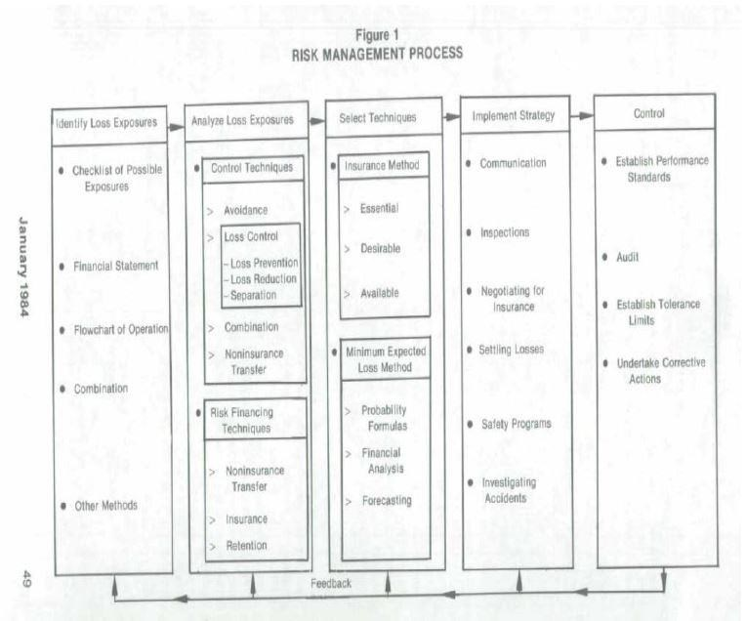
Figure 3. 5-step risk management process. (Hollman et. al, 1984, in Candice Lim, 2010).

2.8.4 Project Risk Management in SMEs
Size and management skills can be either advantages or disadvantages of SMEs. At the minus point, these disadvantages limit SMEs capability when exposing to risks (RS Raghavan, 2005). As SMEs generally divide their operations and management by projects, it is recommendable to look at the common project risks and the definition of project risk management in SMEs. Projects might run on long term or short duration. Long term projects encounter budget risks and uncertainties like market changes, governmental changes, or currency fluctuations.
Shorter projects require shorter time to operate, which means risks may arise from poor estimation of schedule and costs.
Köster (2009) suggest consideration of “local rules” when collaborating in international projects. One country has its typical business attitude and customs, which foreigners might not notice and cannot attempt to change either. For example, local authorities, regarding corruption, bureaucracy and language, might be obstacles for a contract to be signed.
Another factor can lead to a failure project concerning the attitude towards risk taking of SMEs. While needing to grow, SMEs may involve themselves in projects which are out of their ability. Overconfidence is a big challenge in project management (E. Russo, 1990). Project risk management flexibly adapts to the scope of operation; whether it is long term or short-term projects, alternative plans can be modified and adjusted (R. Wideman, 1992). Project risk management is a measure of uncertainties within a projects schedule and an estimation of cost and budget (Chapman C. et al, 1996).
The benefits of project risk management for small businesses lie at the point of time and budget advantages. It is understandable why there are as many models of project risk management as general risk management schemes. Different models introduce diversifying steps and stages of project risk assessment and control. On the other hand, the various models practically maintain the same process of identifying, analyzing, responding, and monitoring risks.

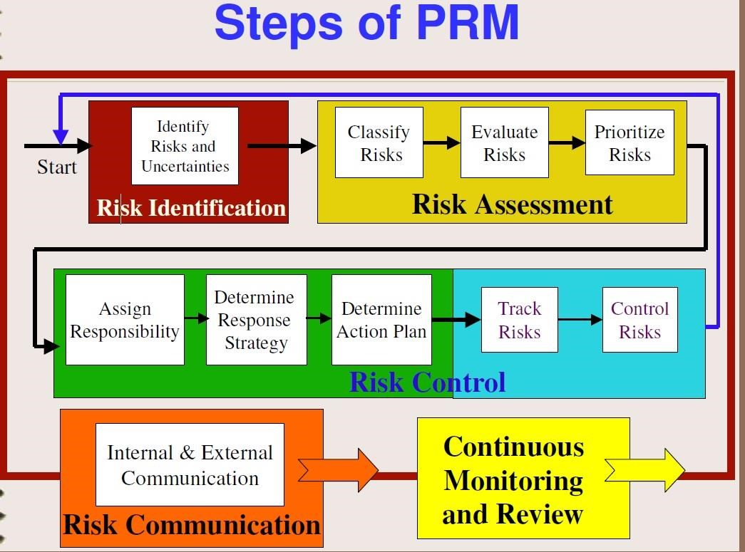
Figure 4. Process of Project Risk Management. (V Ho, 2003)

Figure 4 above is an example of a project risk management process with detail steps dividing into Risk Identification, Risk Assessment, Risk Communication, and Post-Risk Control. In compare to a business strategic risk management scheme, there are two highlights in project risk management that make this approach more suitable for small businesses: the step of planning and identifying risks.
- Risk Planning
Instead of identifying risks as the first step, an adequate project management scheme should start with proper measurement of efforts and planning the assessment and control activities and schedule in advance. It applies also to general risk management, to measure and consider whether the benefits of implementing such a scheme will exceed the efforts and budget against the risks. Risk planning or risk management planning is recognized as major process (Gardiner, 2005. p163).
- Risk Identification
The identification of risks is the ultimate step that decides the end result of the management process. Management should review all the scenarios that may affect the objectives of the project with an open mindset and vision. One method to ensure sufficient risk listing is to screen through the phases of project life cycle (Chapman C. et al, 1986). Common projects cycle through 4 phases of conceptualization, planning, execution and termination; with sub stages and following steps. Referring risks to particular stages and steps will help the management process more efficient and simpler for both the boards of the staffs.
In a report concerning risk management by Harvard Business Review (2011), it is assessed that organizations with a CRO – Chief Risk Officer have considerably more extensive risk planning than other companies. This might be true when comparing large corporates together. Risk managers at small businesses might even not exit, as the management will carry out the risk assessment, at the same time with other management work. The keys to successful project risk management at SMEs and micro companies are to always embed risk management into project management, and to communicate about risks (Bart Jutte), which is a much easier step to be done at smaller than at bigger scale of operation.

2.8.5 Risk Management in Small Technology Firms
Due to the nature of this paper to act as a case study for a micro company in technology service sector, the author will shortly review literature concerning risks and risks management among small technology firms. Nowadays, every business relies, more or less, on technology which duly connects with exposure to risk of technology usage. Compared to other small businesses, high-tech companies have stronger capacity for innovation, higher technology efficiency and, consequently, higher possibilities to expose to technology-related risks. Risks in firms providing technology products or services particularly involve intellectual property, asset and system issues.
While technology requires its own innovative operation systems, the need of manage those systems are equally essential. Equipment like serve and information connection systems should be regularly monitored, tested and backed up to ensure continuous transportation of information and technology products or services.
Key innovations are the soul of technology firms’ operations. Leakage of confidential information will lead to violence of copyright from competitors or from customers; reputational damage and market losses. Technology firms should prepare to patent or register their inventions and products. Proper maintenance of technology output includes confidential agreement with employees and customers to avoid business material being stolen and leaked out.
A research paper by Liang Wenchao and Zhan Baochao of high-tech SMEs in China shows a range of other sources of risks expose to technology firms at initial period of business operation, including shortage in preparation for entrepreneurship establishment, capital, and internal management problems.
2.9 Principles of Insurance
Insurance companies are established to provide financial security to their policy holders through the pooling of premiums, out of which those who suffer unexpected losses are indemnified in as much certain conditions and principles are met and followed respectively. These essential principles include; insurable interest, Utmost good faith, indemnity, subject matter of insurance, contribution, subrogation and proximate cause.
Insurable Interest: Insurable interest is the pecuniary interest in the subject-matter of insurance. The insured must directly suffer from the loss of what is being insured. The policy holder should have monetary relationship with the subject matter (which is recognised by law) and the holder is economically benefited by the survival or existence of the subject matter or suffers economic loss at the loss of the subject matter.
Utmost good faith: This is the doctrine of disclosing all material facts. The insurer and the insured are bound by a good faith bond to honestly and fairness, so material facts (necessary information about the subject matter) must be disclosed.
Indemnity: In the event of loss arising from an insured peril, the insured shall be placed in the same position that he was immediately before the happening of the event insured. This principle is known as Indemnity.
Subject matter of insurance: This is the actual thing, asset or property that is being insured.
Contribution: This principle explains that an insured that insure the same subject matter with more than one insurer cannot be indemnified by all the insurer with the same value of loss but rather the insurer will contribute to the loss on prorate basis.
Subrogation: Since the principle of indemnity is at the root of the law of insurance and the rule is that the insured must not make a profit out of it. To avoid the profit, the insured is not allowed to make claim from the third party. If loss is caused by the third party, the insured is to be compensated by the insurer, who can claim damages from the third party on behalf of the insured.
Proximate cause: Every event that occurs, especially loss, must have a cause. The main cause of loss in insurance is termed, proximate cause. The principle explains that the proximate cause of loss must be covered in insurance contract for the insured to be compensated.
Some Insurance Products Available to SME’s
Fire: This covers the policy holder against the loss or damage to insured property which was caused by an accidental fire.
Business Interruption: This helps to place the business in the same position if there is any loss of turnover / sales/ revenue/income as a result of loss or damage to business property.
Burglary: This ensures that business will be covered against loss from robberies and burglaries which could interrupt business continuity.
Agricultural Insurance: This tends to provide insurance protection to farmers and investors in Agriculture against risks of economic loss associated with modern agriculture. E.g, Nigeria has Nigerian Agricultural Insurance Corporation that focuses on Agricultural insurance.
Liability Insurance: This protects the business in the event that it is held responsible for injuries, death or damage to a third party.
Motor Insurance: ensures protection of vehicle(s) against accidents, theft and many other incidents, depending on the type of cover seeks by the policyholder.
Fidelity Guarantee: Protects the business against losses suffered due to fraud by employees.
Personal Accident: provides insured owners and shareholders with cover for death, disablement and medical expenses after an accident.
2.10 The Role of Insurance in Sustaining Small Businesses
Insurance plays a significant role in sustaining small businesses. Its most important benefit is the identification of unexpected losses, restoring of losses which does not only rebuild economic viability of an organisation but, also strengthen the society at large and its other major importance is the strengthening of small businesses (Tripathy and Pal, 2007). Others:
- Reduced uncertainty of business losses: in case of accident, business could loss its property and even its capital, but insurance provides compensation for losses that may occur in any of the event insured which encourages business activities.
- It increases business efficiency: when the owner of a business is free from fear of losses, as he is going to be compensated, he will certainly devote much time to the business which will maximise firm’s profitability.
- Provides security and safety: Insurance provides safety and security against loss that may occur on a particular event which improves productivity
- Welfare of employee: insurance gives room for employee’s welfare which provides for disability at work, retirement plan and even death plan, which encourage them to put in their best at which, which improves productivity and profitability.
- Basis for collateral: lot of studies show that the risky nature of small businesses makes banks to relax their extension of credit to them but, with insurance coverage, their risk of failure is covered which would make banks to be rest assured that they can get back their money.

CHAPTER THREE
RESEARCH METHODOLOGY
An enquiry into a field of research takes up the form of scientific investigation. It is a finding process where a researcher searches an event or a phenomenon in the quest for interpretive answers. This process involves a critically effective scientific method, which is what the research methodology serves.
An empirical research was carried out, using a questionnaire which was administered to owners or managers of SMEs in Sokoto Metropolitan area. Data was collected through a survey type structured questionnaire that was developed, pretested and validated. The questionnaire was administered to the owners or managers of SMEs in the Metropolitan Area. The target population for the research was business owners within the Area. They form part of the complete group of specific population elements relevant to the research project. A sampling frame was drawn from the population and from that the actual sample was derived. The population and the sample for this study is illustrated in Figure 1.
As this research project adopts a descriptive method in explaining this phenomenon. It will present the analysis in graphs and other descriptive aids for better interpretation and analysis. The specific tools involved in this methodology therefore, include: Population of the Study, Sample and Sampling Technique, Research Instrument, Validity and Reliability, Research Design, Procedure for Data Administration, Method of Data Analysis
3.1 Population of the Study
The population of the study was composed generally small and medium SMEs. To this regard, 203 were selected, which make up the population of the study.

Table 3.1: Population Description
Type of Business | Employees
Small | 5 to 20
Medium | 20 to 200

3.2 Sample and Sampling Technique
The sampling technique that was used was cluster sampling. It was most suitable for because there was heterogeneity between subgroups and homogeneity within subgroups. The SMEs were divided into clusters according to the number of employees as this is consistent with the definition of SMEs which was used for this research. The different clusters had SMEs that had the same number of employees as one cluster, one cluster contained small businesses and the other had medium sized businesses as illustrated:

Type of Business | Employees
Small | 5 to 20
Medium | 20 to 200

Source: Adapted from Zaayman (2003:16).

Sample size
The level of sampling error one is willing to accept in a research influences the sample size. In reality the sample statistic is known but the population statistic is unknown, so, the difference between the sample and the population value can be assessed in terms of the likelihood that a sample value differs by a certain value from the population value (Leedy 2005:35). Cooper and Schindler (2003:190), recommend that since researchers can never be 100% certain that a sample reflects its population; they must decide how much precision they need and in making this decision.
It was estimated that there were approximately 2400 registered SMEs in the Metropolitan Area. The sample size was then calculated using 95% confidence interval with a margin of error of 5%, the sample size was 332 SMEs. There were only 203 respondents who gave back their questionnaires, which represents a 61% response rate.
3.3 Research Instrument
The research instrument adopted for use in this study was a self-structured questionnaire. This questionnaire was divided into two sections with the first section containing the demographic information needed from the respondents while the second was detailed for the collection of data related to the research study.
3.4 Validity and Reliability
The instrument was validated and reliability was tested using Chi-square test and Cronbach’s alpha. The Chi-square test was used to test if a sample of data came from a population with a specific distribution. The data was analysed by using Statistica and Statistical Package for the Social Sciences (SPSS).
3.5 Research Design
A quantitative empirical investigation was preferred above a qualitative design as the aim was not only to describe, emphasize meaning or experiences, but rather to solve the stated problem by analyzing and interpreting data statistically. The study then adopted a descriptive research design.
3.6 Procedure for Data Administration
The data instrument used to collect data was in the form of a self-administered questionnaire distributed to SMEs in the Metropolitan Area.
3.7 Method of Data Analysis
The statistical method which was used to analyse the data is descriptive statistics, Cronbach’s alpha, correlations, simple regression analysis and multiple regression analysis.

CHAPTER FOUR
DATA PRESENTATION AND ANALYSIS

4.1 Data Presentation
The statistical analysis conducted illustrate the extent to which the results yielded answers to the research objectives that underpin the research conducted. The main objective of the research was to determine which factors had the most influence on relationship building between SMEs and Insurance providers. To achieve this objective a questionnaire was administered to SME owners or managers, the following is a profile of the respondents in Table 3 and the size of the business in Table 4.

Biography of respondents

Table 3: Size of The Businesses That Participated

Size of business |  | Frequency | Valid percent
 | Small | 132 | 65
 | Medium | 71 | 35
 | Total | 203 | 100.0

The majority (65%) of the respondents were small businesses and a few of the respondents (35%) medium sized businesses who participated in the research.

Table 4: Occupation of The Participants

Occupation | Frequency | Percent
Owner | 82 | 40.4
Partner | 11 | 5.4
Middle Management | 36 | 17.7
Supervisor | 53 | 26.1
Other | 21 | 10.3
Total | 203 | 100.0

The majority of the respondents were owners of SMEs (40.4%), followed by supervisors (26.1%), middle management (17.7%) and lastly partners (5.4%). This affirms studies carried out by Mutezo (2005: 81) on SMEs in Tshwane where 86% of the respondents were owners of the business. This shows that most SMEs are managed by their owners.

Descriptive Statistics
The descriptive statistics that are provided help to explain the different variables that were used for the hypothesis testing and to help achieve the research objectives for this study.

Table 5: Descriptive Statistics on Insurance Training

Occupation | Yes (%) | No (%)
Insurance related training | 16.7 | 83.3
SMEs owner/managers who want insurance training | 72.1 | 27.9
SMEs who have been approached by insurance brokers | 66 | 34

A large number of the respondents (83.3%) had not received any form of insurance related training and only 16.7% of the respondents received insurance training. The study shows that, 72.1% of the respondents want to be trained on short term insurance related matters and 27.9% do not want any training. Sixty six percent of the SME managers/owners who participated in the research had been approached by an insurance broker within the past six months and 34% had not been approached. These variables were used to establish the existence of a relationship between SMEs and insurance providers.

4.2 Hypothesis Testing
Researchers must demonstrate instruments are reliable since without reliability, results are not replicable. Reliability analysis can be used to measure the consistency of a questionnaire. Cronbach’s alpha is the most common form of internal consistency reliability coefficient. Cronbach’s alpha (Į) indicates the overall reliability of a questionnaire and values around 0.8 and 0.7 are good for ability tests (Field 2009:675). The following is a table summarising the results of the reliability tests done on the two hypotheses tested for this research.

Reliability Tests
Table 6: Cronbach’s alpha (Į) Hypothesis
0.698 | H¹ | The level of training in the field of short-term insurance and the factors influencing the purchase of insurance by SME managers or owners has an effect on their relationship with insurance brokers;
0.802 | H₂ | SMEs who have an insurance policy and have been approached by insurance broker have a business relationship with insurance providers.

4.2.1 Primary Hypothesis
H0: The level of training in the field of short-term insurance and the factors influencing the purchase of insurance by SME managers or owners has no effect on their relationship with insurance brokers;
H1: The level of training in the field of short-term insurance and the factors influencing the purchase of insurance by SME managers or owners has an effect on their relationship with insurance brokers;
Having training, the factors influencing the purchase of an insurance policy and having a business-to-business relationship, all had high reliabilities, all Cronbach’s Į =.7. A multiple regression analysis1 as well as, Analysis of variance (ANOVA) were employed to test statistically, the significance of the null hypothesis.
Table 7: Multiple Regression Model for The Effect of Insurance Training and Factors Influencing The Purchase Of Insurance On Business-To-Business Relationship
Model | R | R Square | Adjusted R Square | Std. Error of the Estimate
1 | .309ª | .095 | .089 | .385
2 | .554^{b} | .307 | .260 | .347
a. Predictors: (Constant), Insurance training
b. Predictors: (Constant), Insurance training, Cost, Advantages, Affordability, Durability, Brand Of Insurer, Type of Policy, After Sales
Care, Disadvantages

The value of R² in Model one is .095, which shows that insurance training account for 9.5% of the variation in SMEs business-to-business relationship with insurance providers. Model two which regresses the factors influencing the purchase of insurance policy by SMEs and their business-to-business relationship has R² = .307, which means that these factors account for 30.7% of the variation in SMEs business-to-business relationship. The next table of analysis is the ANOVA.

Table 8: Anova Results Showing the Effect of Insurance Training and The Factors Influencing The Purchase of Insurance on Business-To-Business Relationship

Model |  | Sum of Squares | Df | Mean Square | F | Sig.
1 | Regression | 2.201 | 1 | 2.201 | 14.839 | .000ª
 | Residual | 20.917 | 141 | .148
 | Total | 23.119 | 142
2 | Regression | 7.097 | 9 | .789 | 6.546 | .000^{b}
 | Residual | 16.022 | 133 | .120
 | Total | 23.119 | 142
a. Predictors: (Constant), Insurance training
b. Predictors: (Constant), Insurance training, Cost, Advantages, Affordability, Durability, Brand Of Insurer, Type of Policy, After
Sales Care, Disadvantages
c. Dependent Variable: Business-to-Business Relationship with Insurer

ANOVA aims to show whether the model, overall, results in a significantly good degree of prediction of the outcome variable (Field, 2009:208). When tested at 95% confidence interval and 5% margin of error, the results reported that training and the factors influencing the purchase of insurance have a significant effect on the business-to-business relationship between SMEs and insurance providers. This can be seen from a p-value of .000 in table 6, which indicates significance of the model.

Table 9: Multiple Regression Analysis for The Effect of Insurance Training And Factors Influencing The Purchase of Insurance On Business-To-Business Relationship

Coefficientsª
Model |  | Unstandardized Coefficients |  | Standardized Coefficients | t | Sig.
 |  | B | Std. Error | Beta
1 | (Constant) | .595 | .161 |  | 3.691 | .000
 | Insurance training | .401 | .104 | .309 | 3.852 | .000
2 | (Constant) | 1.780 | .540 |  | 3.296 | .001
 | Insurance training | .343 | .107 | .264 | 3.211 | .002
 | Brand Of Insurer | -.197 | .065 | -.244 | -3.055 | .003
 | Affordability | -.233 | .073 | -.267 | -3.179 | .002
 | Advantages | -.124 | .054 | -.191 | -2.293 | .023
 | Disadvantages | .064 | .050 | .106 | 1.283 | .202
 | Durability | .039 | .045 | .069 | .870 | .386
 | Cost | .035 | .099 | .028 | .355 | .723
 | After Sales Care | .024 | .031 | .064 | .777 | .439
 | Type of Policy | -.014 | .086 | -.013 | -.166 | .869
a. Dependent Variable: Business-to-Business Relationship with Insurer

It was further observed that the factors that influenced the purchase of insurance such as the brand name of insurer (p = .003), affordability (p = .002) and advantages (p = .02) have a significant effect on the business-to-business relationship between SMEs and insurance providers. Statistically this means that these factors can determine the existence or non-existence of a business-to-business relationship between SMEs and insurance providers.
Statistically, the null hypothesis is rejected and the alternative hypothesis is accepted. It is concluded that: The level of training in the field of short term insurance and the factors influencing the purchase of insurance by SME managers or owners has an effect on their relationship with insurance brokers.

4.2.2 Secondary Hypothesis
H0: SMEs who have an insurance policy and have been approached by insurance broker do not have a business relationship with insurance providers;
H2: SMEs who have an insurance policy and have been approached by insurance broker have a business relationship with insurance providers.
The type of insurance, having an insurance policy, approached by insurance broker and business-to-business relationship, all had high reliabilities, all Cronbach’s Į = .8. ANOVA (Analysis of variance) as well as multiple regression were used to test the statistical significance of the hypothesis.

Table 10: Anova Results Showing How Being Approached By An Insurance Broker And Having An Insurance Policy Affect The Business-To-Business Relationship Between Smes And Insurance Providers

Model |  | Sum of Squares | df | Mean Square | F | Sig.
1 | Regression | 1.947 | 2 | .974 | 7.219 | .001ª
 | Residual | 21.986 | 163 | .135
 | Total | 23.934 | 165
2 | Regression | 5.265 | 12 | .439 | 3.596 | .000^{b}
 | Residual | 18.668 | 153 | .122
 | Total | 23.934 | 165
a. Predictors: (Constant), Approached by Broker, Have Insurance Policy
b. Predictors: (Constant), Approached by Broker, Have Insurance Policy, Employee Dishonesty, Personal liability, Other, Public Liability, Buildings, Employee's Liability, Contents, Risk, Vehicle/fleet\, Electronic equipment, Stock & Money
c. Dependent Variable: Business-to-Business Relationship with Insurer

There are two models that were fitted into our multiple regression analysis. The first model, Model one included having an insurance policy and being approached by broker. These factors had an effect on business-to-business relationship between SMEs and insurance providers, F (2.163) = 7.23, p< .05. Model two included the type of insurance held by SME owners/managers for their business and this was also found to be significant with a p<.05.

Table 11: Regression Analysis Showing How Being Approached By An Insurance Broker And Having An Insurance Policy Affect The Business-To-Business Relationship Between SMEs And Insurance Providers

Model |  | Un-standardised Coefficients |  | Standardised Coefficients | t | Sig.
 |  | B | Std. Error | Beta
1 | (Constant) | .916 | .122 |  | 7.508 | .000
 | Have Insurance Policy | -.032 | .058 | -.041 | -.545 | .586
 | Approached by Broker | .243 | .064 | .286 | 3.794 | .000
2 | (Constant) | 1.028 | .427 |  | 2.406 | .017
 | Have Insurance Policy | -.053 | .106 | -.069 | -.504 | .615
 | Approached by Broker | .169 | .065 | .200 | 2.595 | .010
 | Vehicle/fleet\ | .028 | .096 | .036 | .287 | .774
 | Buildings | -.244 | .086 | -.283 | -2.840 | .005
 | Contents | .118 | .106 | .131 | 1.106 | .271
 | Electronic equipment, Stock & Money | -.224 | .118 | -.259 | -1.901 | .059
 | Public Liability | .011 | .099 | .011 | .116 | .908
 | Personal liability | .133 | .079 | .159 | 1.692 | .093
 | Employee's Liability | .285 | .108 | .273 | 2.631 | .009
 | Employee Dishonesty | .051 | .172 | .023 | .298 | .766
 | Risk | .158 | .092 | .192 | 1.715 | .088
 | Other | -.291 | .128 | -.182 | -2.276 | .024
a. Dependent Variable: Business-to-Business Relationship with Insurer

It was further observed (refer to the table above) in the first model that being approached by an insurance broker is significant (p = .000) in predicting the business relationship between SMEs and insurance providers. Whilst having an insurance policy (p> .05) is not necessarily a predictor of having a business relationship with insurance providers.
In model two, having an insurance policy that covers buildings, electronic equipment, stock & money, personal liability, employees liability and other insurance policies were seen to be significant with p-values less than .05.

Fig 2: SMEs who have insurance policies, have a business relationship with insurance providers and have been approached by an insurance broker

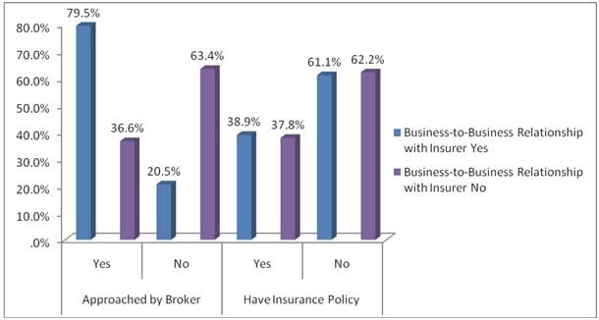

The graph illustrates that 79.5% of the respondents who agreed to having been approached by an insurance broker and 38.9% who agreed to have an insurance policy also agreed to having a business relationship with an insurance company. Of those who had not been approached by an insurance broker 20.5% said yes to having a business relationship with an insurance company, 61.1% respondents without an insurance policy had a business relationship with insurance providers.
The study shows that 62.2% of the respondents who did not have an insurance policy did not have a relationship with an insurance company, and 63.4% who were not approached by an insurance broker did not have a relationship with an insurance company. The results also illustrated that 36.6% of the SMEs who were approached by an insurance broker did not have a business relationship with an insurance company. Of those respondents who had insurance policies 37.8% did not have a relationship with an insurance company.
Hence, statistically we reject the null hypothesis and conclude that alternative hypothesis which states that: SMEs who have an insurance policy and have been approached by insurance broker have a business relationship with insurance providers is accepted.
The primary and secondary null hypotheses were both rejected and the null hypotheses were accepted. The results illustrated that there were many factors that influenced the business-to-business relationship between SMEs and insurance providers. The main factors such as the brand name of insurer, affordability and advantages had a significant effect on the business-to-business relationship between SMEs and insurance providers. The results also highlighted that, there was a significant relationship between businesses that had been approached by insurance brokers and their having a business-to-business relationship with an insurance provider.

4.3 Discussion of Results
The conclusion reached through the results is that factors such as the reliability of an insurer, staff knowledge and brand name of the insurer have a great impact on the decision made by SME to build a relationship with insurance providers. Research revealed that the respondents who had been approached by an insurance broker, 79.5% of the SME owners/managers had a business relationship with an insurance provider. This helps to reach a conclusion that any form of interaction between SME owners/managers and insurance providers helps to facilitate a business relationship.
The results reveal that only 16.7 % of SME owners/managers had any form of training on short term insurance and most of them (72.1%) want to be trained in this field. The training of SME owners/managers is crucial for the relationship building process between SMEs and insurance providers. This shows that SME owners/managers had not been offered any form of training or informative workshops by insurance providers. Although, more than half (66%) of SMEs had been approached by an insurance broker. This leads to the conclusion that SMEs are not aware of the different insurance products that are available to them in order to mitigate the risk they face. There is unpredictable weather phenomenon that is occurring around world. These adverse conditions can result in floods, fires and other natural disasters, because of these and many other disasters that can occur SME owners/managers need to be prepared. The government can put in place legislation that enforces SME owners/managers to have insurance policies that cover their employees and their assets. This is a way to ensure that SMEs are protected from any form of crisis that may result in their closure and resulting in the owners and their employees going to the job market and adding on to the list of the unemployed.

CHAPTER FIVE

SUMMARY, RECOMMENDATIONS AND CONCLUSION
5.1 Summary
The study has shown that there are many factors that influence the business relationship between SMEs and insurance providers. It is recommended that insurance providers should increase their interaction with SMEs. They need to hold frequent workshops for SMEs where they can get a chance to inform them of their various product offerings. Insurance providers can hold research programs twice a year, where they can be able to find out what sort of insurance cover they need to offer SMEs and at the costs that they can afford.
One of the major factors that influenced the relationship building process between SMEs and insurance providers is the reliability of the insurer (96%). Insurance providers can use workshops, road shows and they can hold summits where they can invite SMEs. This will give them a chance to interact with their clients and create a platform where they can provide information concerning their premiums and pay outs when a claim has been made. Insurance providers need to build a relationship with SMEs and trust should be the foundation. They need to train their staff on how to deal with SME owners/managers, their products and payment plans as well as claims. This is all part of the relationship building process.
The study revealed that 72.1% of the SME owners/managers want to be trained on insurance. Insurance providers can therefore, hold frequent workshops and training sessions with SME owners/managers so that they can have an understanding of the type of insurance policy covers that their businesses need , the premiums and how insurance claims can work for them. Based on the number of SME owners/managers who have been trained, insurance providers are not holding needs analysis with their client (SMEs).
SME owners/managers expressed an interest in short term insurance by indicating their willingness to be trained in this field. There were 83.3% of SME managers/owners who had not received any form of training or workshops on insurance. The government needs to ensure that insurance providers follow the law and if they fail to meet the requirements stiffer penalties need to be introduced. In other words, the government should amend the Act and introduce stiffer penalties to those who default. The government can also look into giving incentives to insurance providers so that they develop insurance products that suit the particular needs of the SME sector. This would result in a more stable and sustainable SME sector which will create jobs and help with the fight against poverty.
5.2 Recommendations
The following recommendations were suggested to ensure the sustainability of Micro, Small and Medium Enterprises, which are very essential for poverty alleviation as well as economic growth and development in the developing nations.
- The small business owners and their staff should be trained on various forms of risk that their business could be exposed to and how to manage such risks.
- The government regulating agency (SMEDAN) should ensure that small businesses take insurance coverage to ensure business continuity.
- The government should establish a specialised microinsurance scheme or agency for the SME’s, just like that of National Health Insurance Scheme (NHIS) or Nigerian Agricultural Insurance Corporation (NAIC), to enhance easy and cheaper accessibility to insurance products by the small business owners.
- The government through the National Insurance Commission (NAICOM) should mandated insurance companies to have a specific percentage of small business owners covered.
- The small business owners should continuously be sensitised on various insurance products and the importance of insurance coverage on business continuity.
5.3 Conclusion
The developing nation are seriously fighting with poverty for decades and the agitation for solution brings about the focus on small businesses, which are very essential for the growth of developing nations and most especially for job creation, wealth creation and poverty alleviation. But all businesses are exposed to one form of risk or the other which deter the performance and objectives of the business firms. So, to maintain the achievement expected from them (small businesses), they need to be sustained, their continuity needs to be assured and their risk need to be covered, which could be done with the aiding tool of insurance. It was discovered from this study that small business owners have problem of financing and banks see the sector to be too risky for giving them loan as majority of them (small business owners) do not take insurance coverage despite the riskiness of the sector and most of them do not have essential knowledge of insurance products available to them as well as their importance to business continuity.

REFERENCES

Aliber, M. 2002. South African Microinsurance Case Study. Geneva: International Labour Organisation.
African Development Bank and OECD Development Centre. 2005. African Economic Outlook. Available: http://www.oecd.org/ dev/publications [accessed: 1 April 2008];
Brink, A. & Berndt, A. 2004. Customer Relationship Management and Customer Service. Lansdowne: Juta & Co.Ltd;
Claro, D.P. 2004. Coordinating Business-to-Business Cross Border Supply Chains: The Case of the Organic Coffee Industry. Available:
http://www.emaraldinsght.com [accessed: 5 March 2008];
Cooper, D.R. & Schindler, P. 2003. Business Research Methods. 8th edition. New York: McGraw-Hill;
Cronje, G. J.J., Du Toit, G.S. & Motlatla, M.D.C. 2003. Introduction to Business Management. 5th Edition. Cape Town: Oxford University Press;
Daniels, L. 1998. What drives the small-scale enterprise African entrepreneurship: Theory and reality. Gainesville Florida: University of Florida Press;
De Vos, A.S. 2002. Research at grass roots: for the social sciences and human services professions. Pretoria: Van Schaik;
Dumaine, B. 1993. Times Are Good? Create A Crisis. Fortune, Chicago, (127)13: 123-127;
European Commission Recommendation. 2003. Official Journal of the European Union. 124, p. 36 of 20 May 2003;
Elsubbaugh, S., Fields, R. & Rose, M.B. 2004. Preparation for Crisis Management: A Proposed Model and Empirical Evidence. Journal of Contingencies and Crisis Management, (12)3: 112-127;
Field, A. 2009. Discovering Statistics Using Spss Third Edition. London: Sage Publications Ltd;
Finweek. 2012. Fragmented approach to assisting SME’s is inefficient. Available: http://www.finweek.com/2012/11/13/fragmentedapproach-to-assisting-smes-is-inefficient/ [accessed: 15 May 2013];
Garson, D. Chi-square Tests: Statsnotes from North Carolina State University. Available: http://www.faculty.chass.ncsu.edu/garson/2009 [accessed: 10 November 2011];
Gregory, G., Harvive, C., & Lee, H. 2002. Korean SMEs in the Wake of the Financial Crisis: Strategies, Constraints, and Performance in a Global Economy. Working Paper Series, University of Wollongong;
Independent Online (IOL) News. 2008. Flood havoc in KZN. Available: http://www.iol.co.za [accessed: 15 November 2012];
Investors Words. 2007. Available: www.investorswords.com [accessed: 20 March 2011];
Keats, B.W. and Bracker, J.S. 1988. Toward a theory of small firm performance: a conceptual model. American Journal of Small Business. Spring: 41-58;
KNC & Associates. 2002. Access to Finance. Presentation to APDF Conference;
Leedy, P.D. & Ormrod, J.E. 2001. Practical Research: Planning and Design. 7th Edition. New York: Upper Saddle River, N.J: Pearson Prentice Hall;
Leedy, P.D. 2005. Practical Research: Planning and Design. New York: Prentice Hall;
Little, E. & Marandi, E. 2003. Relationship Marketing Management. London: Thomson Learning;
Longenecker, J.G, Moore, C.W. & Petty, J.W. 2003.Small Business Management: An Entrepreneurial Emphasis. Ohio: Thomson Southern-Western;
Longenecker, J.G. Moore, C.W. & Petty, J.W. 2000. Small business Management: An Entrepreneurial Emphasis. London: SouthWestern College Publishing;
OECD. 2010. “Entrepreneurship and Migrants’, Report by the OECD Working Party on SMEs and Entrepreneurship, OECD. Available: www.oecd.org/dataoecd/34/18/45068866.pdf [accessed: 15 May 2013]
Macgregor, D. 2012. Eastern Cape counts costs of floods. Times Live, October. Available: www.timeslive.co.
za/thetimes/2012/10/25/estern-cape-counts-costs-of-floods [accessed: 15 May 2013];
Mahembe, E. 2011. Literature review on Small and Medium Enterprises’ Access to Credit and Support in South Africa.Available:
www.ncr.org.za/pdfs/Literature%20Review%20on%20SME%20Access%20ro%20Credit%20in%20South%20AfricaFinal%Report NCRDec%201211.pdf [accessed: 15 May 2013]
Manning, A. 2002. Business Interruption and Claims - A Practical Guide. 2nd Edition. Camberwell: Manning’s of Manning; Manning, A. 2004. Strategic Management of Crises in Small and Medium Businesses. PhD thesis, Victoria University, Australia;
Megginson, W.L., Byrd, M.J., Scot C.R. & Megginson, L.C. 1997.Small Business Management. Boston: McGraw-Hill Companies;
Ministry of Trade and Industry. 1994. Strategies for the development of an integrated policy and support program for Small, Medium and Micro enterprises in South Africa. A discussion paper. Government Publications;
Mitroff, I. 2000. Managing Crises Before They Happen. New York: AMACON;
Moore, C.W, Petty, J.W, Palich, L.E. & Longenecker, J.G. &. 2008. Managing Small Business: An Entrepreneurial Emphasis. Ohio: South-Western Cengage;
Mouton, J. 2001. How to succeed in your master’s and doctoral studies: a South African guide and resource book. Pretoria: Van Schaik; Mthimkhulu, V. 2008. New Deal In The Offering for SMMEs. Enterprise, May, pp 10-18;
Mutezo, A. T. 2005. Obstacles in the access to SMME finance: an empirical perspective on Tshwane. Unpublished master’s thesis, University of South Africa, South Africa;
Ntsika. 2002. State of Small Business in South Africa: Annual Review. Enterprise Promotion Agency. Pretoria;
Rwigema, H. & Venter, R. 2004. Advanced Entrepreneurship. Cape Town: Oxford University Press Southern Africa;
Ryals, L.J. 2006. Profitable Relationships with keys customers: How suppliers manage pricing and customer risk. Journal of Strategic Marketing, Vol.14 (2), 101-113;
SBA (Small Business Administration). 2004. What is a small business? Available: www.sba.gov/businessop/standards/smallbus.htm [accessed: on 06 May 2012];
Small Enterprise Development Agency (SEDA). 2008. SEDA – Who we are. Available: http://www.seda.org.za/content.asp [accessed: 27 April 2012];
Shepard, D.A., Douglas E.J. & Shanley, M. 2000. Ignorance external shocks, and risk reduction strategies. Journal of business Venturing, Vol.15. 393-410;
Smits, S.J. & Ezzat, N. 2003. Thinking the Unthinkable: Leadership’s Role in Creating Behavioural Readiness for Crisis Management. Competitiveness Review, 13(1): 1-23;
South Africa. 1996. National Small Business Act number 102 of 1996. Pretoria: Government Printers;
South Africa. 1998. Short-Term Insurance Act of 1998. Pretoria: Government Printers;
South Africa. Financial Advisory and Intermediary Services Act 37 of 2002;
South African Broadcasting Cooperation (SABC) News. 2009. Cape Town hit by floods. Available: http://www.sabcnews.com [accessed: 06 January 2010];
South African Broadcasting Cooperation (SABC) News.2006.Southern Cape Flood damage estimated at R400million. Available: http://www.sabcnews.com [accessed: 31 March 2010];
Statistics South Africa (SSA). 2013. Quarterly Labour Force Survey: Quarter 4 (October To December), 2012 Press Statement.Available:
http://www.statssa.gov.za/news_archive/press_statements/QLF-Q4-2012.pdf [accessed: 16 April 2013];
Strut, R.S.G. 1998. “Why Insurance”, Captive Insurance Company Review. April 1998, pp8-11;
Taymaz, E. 2005. Are Small Firms Really Less Productive? Small Business Economics, Vol.25. pp 429-445;
Valsamakis, A.C., Vivian, R.W. & Du Toit, G.S. 2005. Risk Management: Managing Enterprise Risks. 3rd Edition. Sandton South Africa:
Heinemann Publishers;
Van der Nest, D. 2004. The Impact of Black Economic Empowerment on the Management of Small Companies in South Africa. Unpublished Master’s Dissertation. Rand Afrikaans University;
Wegner, T. 2003. Quantitative methods for marketing decisions. Cape Town: Juta;
Welman, J.C. & Kruger, S.J. 2001. Research Methodology for Business and Administrative Sciences. Cape Town: Oxford University Press;
Zaayman, P. 2003. Financial Requirements of eCRM Solutions for the South African SME Sector. Published Master’s dissertation. Rand Afrikaans University, South Africa;
Zikmud, W.G. 2003. Business Research Methods. 7th edition. Australia: Thomson South-Western.

